**Single Phase Thyristor Configuration**

Single Phase Thyristor configuration is a commonly used topology for rectifing AC signals.Although this configuration has many advantages,it also has disadvantages either.

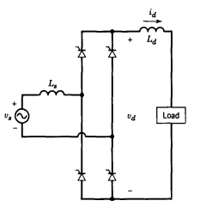

Figure 1:Schematic of Single Phase Controlled Rectifier

DC motor can be represented as a series resistance R and series inductance L as in the figure above.

As can be seen from figure 2 ,this rectifier converts the AC signal to DC signal and drives the motor.

-The Advantages of this topology;

1. It’s four quadrant operation is much simpler than diode rectifier-buck converter configuration.
2. Cheaper
3. Easier to achieve simplicity bonus

-The Disadvantages of this topology;

1. Aranging and synchronizing the firing angle of the gate signal
2. Gate driving circuit is hard to implement

As all engineering applications,this topology has advantages and disadvantages.